ConvFinQA

# Introduction

**Retriever side**

* **Main.py** (in finqanet_retriever/) → trains the retriever model.
* **Test.py** → runs the retriever to produce predictions (retriever_outputs.json).

**2. Generator side**

The generator doesn’t directly eat the retriever’s raw JSON.  
It expects structured input with question + retrieved evidence in a specific format.

* **Convert.py** (in finqanet_generator/)
  + A preprocessing script.
  + Reads the retriever’s output (retriever_outputs.json).
  + Transforms it into a generator-ready dataset (e.g., generator_input.json).
  + This is a **one-time transformation step**, not training.
* **Main.py** (in finqanet_generator/)
  + This is the **training entry point** for the generator model (seq2seq).
  + It takes the converted data (generator_input.json) as --train_file, --dev_file, etc.
  + Trains the model to generate reasoning steps and answers.
* **Test.py** (in finqanet_generator/)
  + Runs inference with a trained generator model.
  + Produces final predicted answers.

# 0. Train the retriever

cd /home/francis/tomoro/ConvFinQA/code/finqanet_retriever

python Main.py \

  --train_file ../../data/train_turn.json \

  --valid_file ../../data/dev_turn.json \

  --output_dir ./output

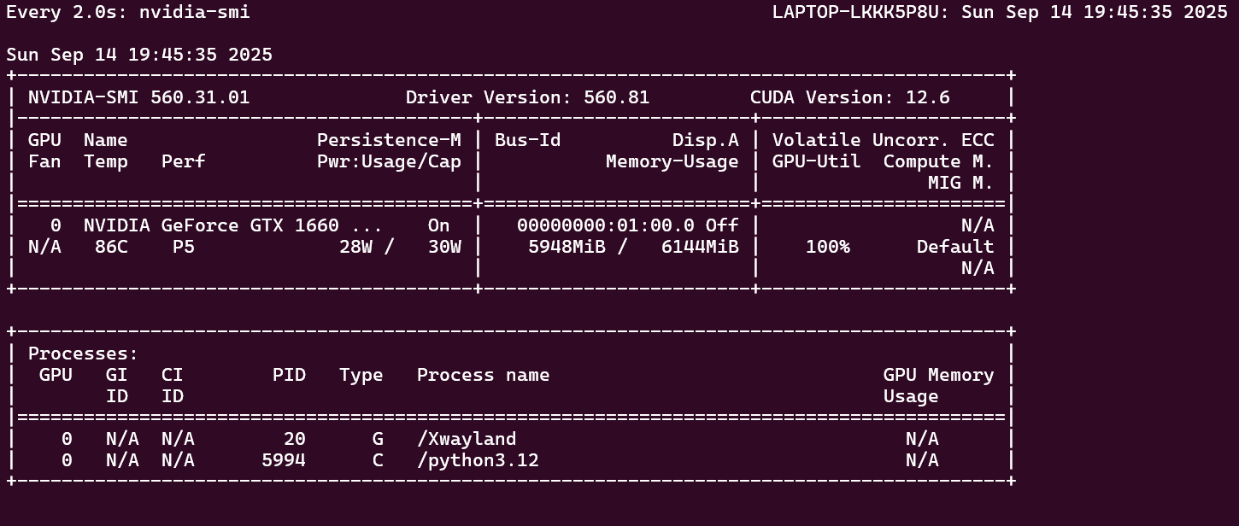

nvidia-smi confirms the retriever training is using your **GTX 1660 (6 GB)** GPU at 100% load. Perfect 👍

**🔎 What is saved in the .pt file?**

The file you see (model.pt) is a **PyTorch checkpoint** created by:

torch.save(model.state_dict(), os.path.join(save_dir, "model.pt"))

That means:

* It does **not** include the full model object.
* It includes only the **weights (parameters)** of your retriever model (Bert_model).
* It’s a mapping: { "layer_name": tensor, ... }.

So the .pt file holds:

* The RoBERTa encoder weights (fine-tuned on ConvFinQA retrieval task).
* The retriever’s classifier head weights (layers predicting supporting facts).
* No optimizer state (so you can’t resume training exactly, unless you modify code).

**🔧 How it’s used later**

In Test.py, the code will:

model = Bert_model(...)

model.load_state_dict(torch.load(model_path))

model.eval()

* model_path points to your model.pt.
* This re-creates the retriever with the learned weights.
* Then it runs inference on your dev_turn.json or test_turn.json file.
* Outputs: retriever_outputs.json → the predicted relevant sentences/table rows.

**✅ Summary**

* The .pt file = trained retriever **weights only** (no full model/optimizer).
* You use it in Test.py to generate retriever predictions.
* Then Convert.py transforms those predictions into generator inputs.

## Models

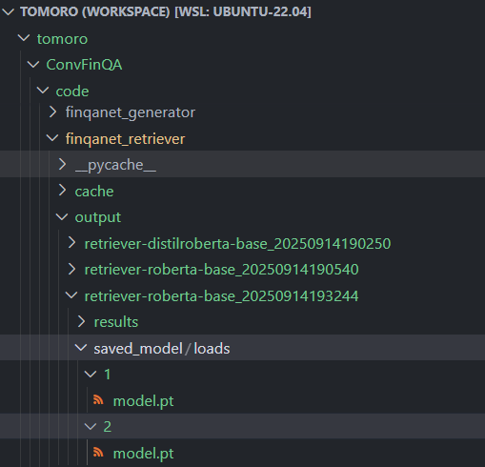

**🔜 Next steps in the pipeline**

# 1. Evaluate the retriever

Run the test script with your saved model:

python Test.py \

  --model_path output/retriever-roberta-base_20250914193244/saved_model/loads/2/model.pt \

  --test_file ../../data/dev_turn.json \

  --save_path retriever_outputs.json

# Replace <timestamp> with the actual folder name you saw.

# This will run the retriever on the dev set and write predictions (retriever_outputs.json).

That command is running your **trained retriever** in inference/evaluation mode.  
Let’s break it down line by line:

**1. Load the trained model**

--model_path output/retriever-roberta-base_20250914193244/saved_model/loads/2/model.pt

* Loads the retriever model weights you trained (model.pt).
* Initializes the retriever architecture (Bert_model) and fills in all the learned parameters.
* Switches the model into eval() mode (no training, just inference).

**2. Read the test/dev dataset**

--test_file ../../data/dev_turn.json

* Opens the **dev set** of ConvFinQA.
* Each example = a conversation turn (question + history + financial report).
* The dev file also includes **gold supporting facts** so evaluation can measure accuracy.

**3. Run retrieval**

* For each example, the model:
  1. Encodes the question and candidate report sentences/rows with RoBERTa.
  2. Scores which sentences/rows are most relevant.
  3. Selects the top-k (based on conf.topn, usually 5).

So the retriever is trying to answer: *“Which parts of the report are relevant for this question?”*

**4. Save predictions**

--save_path retriever_outputs.json

* Writes predictions to retriever_outputs.json.
* Each entry looks something like:
* {
* "id": "turn_001",
* "predicted_supports": [
* "page_85_sentence_3",
* "page_86_sentence_1",
* "table_row_5"
* ]
* }

**5. Evaluate performance**

* Since you used **dev set**, Test.py will compare predictions with the gold supporting facts in dev_turn.json.
* Metrics like **recall@k** (how often the gold evidence is in top-k) will be printed and logged.
* If you had used test_turn.json, there would be no gold labels → only predictions would be saved.

✅ **Summary:**  
This command takes your trained retriever checkpoint, runs it on the dev set, and outputs both:

* Quantitative metrics (retriever accuracy).
* A JSON file (retriever_outputs.json) containing the predicted supporting facts, which will be the input for the **generator** stage.

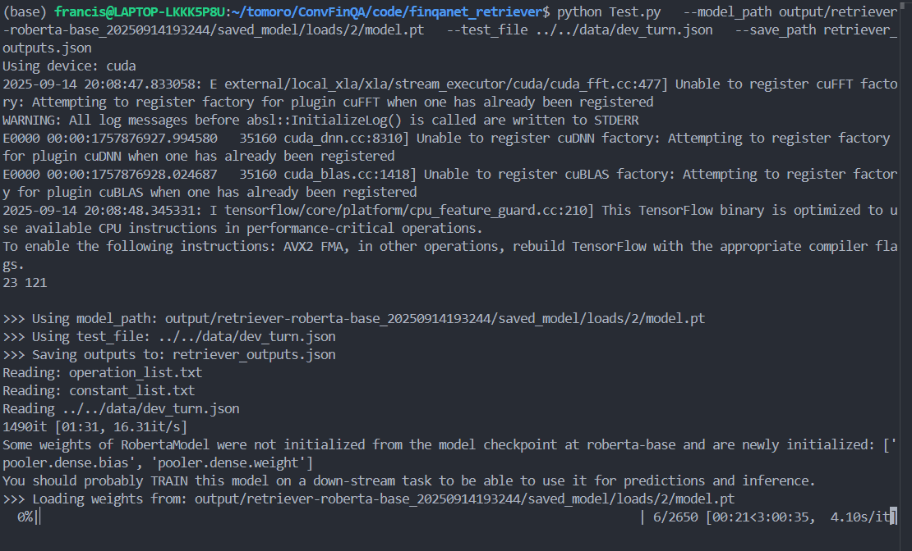

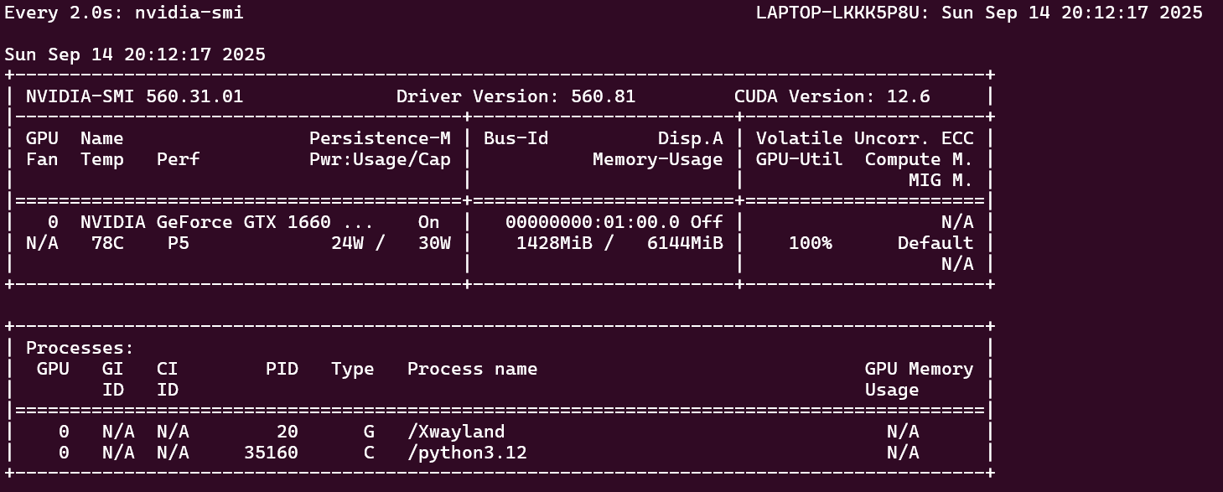

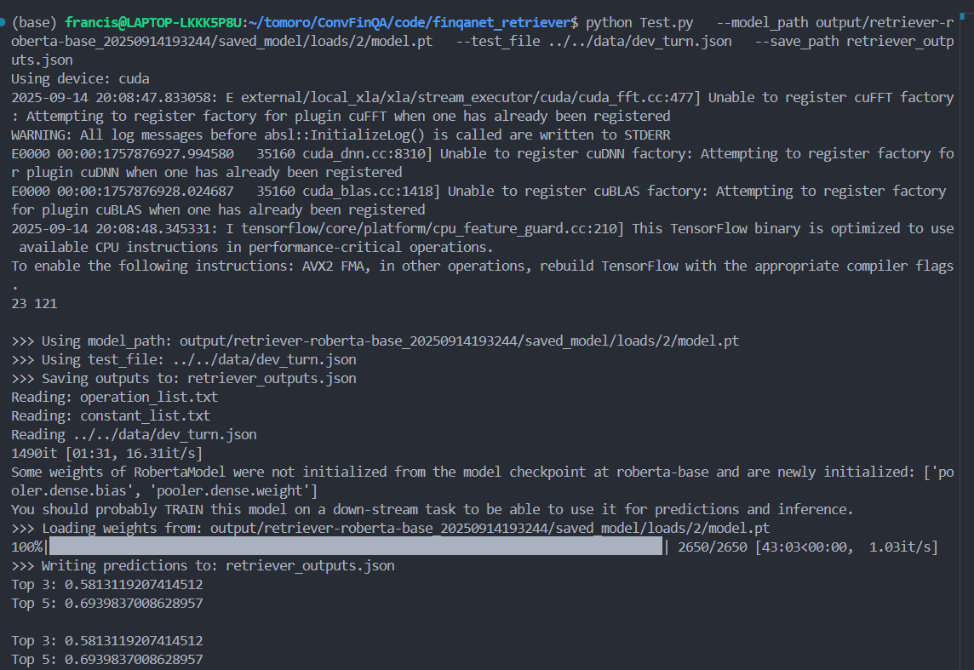

# 2. Convert retriever outputs for generator

Now feed the retriever predictions into the generator stage:

cd /home/francis/tomoro/ConvFinQA/code/finqanet_generator

python Convert.py \

  --retriever_file ../finqanet_retriever/retriever_outputs.json \

  --save_path ./dev_retrieve.json \

  --split dev

[convert_test] Wrote 1490 examples to ./dev_retrieve.json

* dev_retrieve.json → 1490 examples (one per conversation turn in dev_turn.json)  
  This file contains:
  + the question
  + the gold answer
  + annotated reasoning program
  + the **retrieved evidence**, already reduced to topn=3 snippets (table rows + text)

This is exactly what the **generator’s Main.py** expects for training or evaluation.

# 3. Train the generator

export HF_HOME=$HOME/.cache/huggingface

export TRANSFORMERS_CACHE=$HOME/.cache/huggingface/transformers

# make sure you use the HF cache you configured

echo $HF_HOME

# optionally, run with more connections

pip install hf_transfer

export HF_HUB_ENABLE_HF_TRANSFER=1

python Main.py \

  --train_file ./dev_retrieve.json \

  --valid_file ./dev_retrieve.json \

  --test_file  ./dev_retrieve.json \

  --output_dir ./generator_ckpt \

  --mode train

* The generator learns to map input → gold programs.

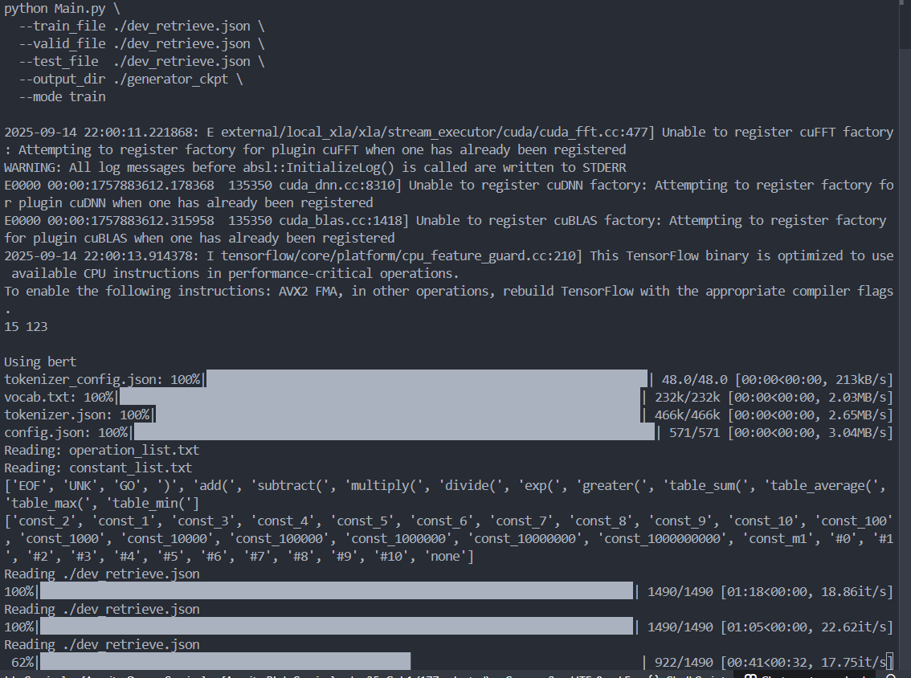

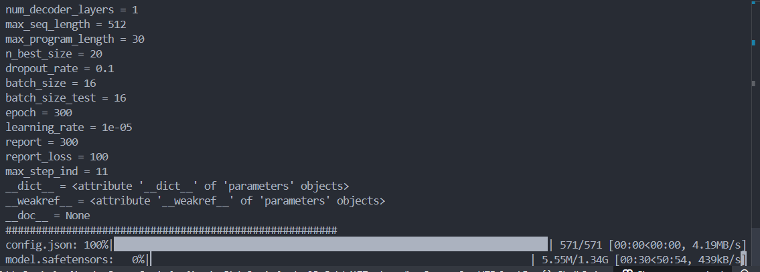

# 4. Evaluate generator

export FINQA_GEN_CKPT=./generator_ckpt/generator-bert-base-try_20250914225507/saved_model/loads/21/model.pt

cd /home/francis/tomoro/ConvFinQA/code/finqanet_generator

python Convert.py \

  --retriever_file ../finqanet_retriever/retriever_outputs.json \

  --save_path ./test_retrieve.json \

  --split test

export FINQA_GEN_CKPT=./generator_ckpt/generator-bert-base-try_20250914225507/saved_model/loads/21/model.pt

python Main.py \

  --test_file ./test_retrieve.json \

  --output_dir ./generator_ckpt \

  --mode test

